**Atlanta Population**

1.use db.zipcodes.find() to filter results to only the results where city is ATLANTA and state is GA.

Answer- db.zipcodes.find({city:'ATLANTA',state:'GA'})

2. use db.zipcodes.aggregate with $match to do the same as above.

Answer-db.zipcodes.aggregate([{$match:{city:'ATLANTA',state:'GA'}}])

3. use $group to count the number of zip codes in Atlanta.

Answer- db.zipcodes.aggregate([{$match:{city:'ATLANTA'}},{$group:{_id:'$_id'}},{$count:'uni_zipcode'}])ggregate([{$uni_zipcode: 41 }

4. use $group to find the total population in Atlanta.

Answer-

db.zipcodes.aggregate([{$match:{city:'ATLANTA'}},{$group:{_id:'city',totalpop:{$sum:'$pop'}}}])

{ _id: 'city', totalpopulation: 630046 }

**Populations By State**

1.use aggregate to calculate the total population for each state

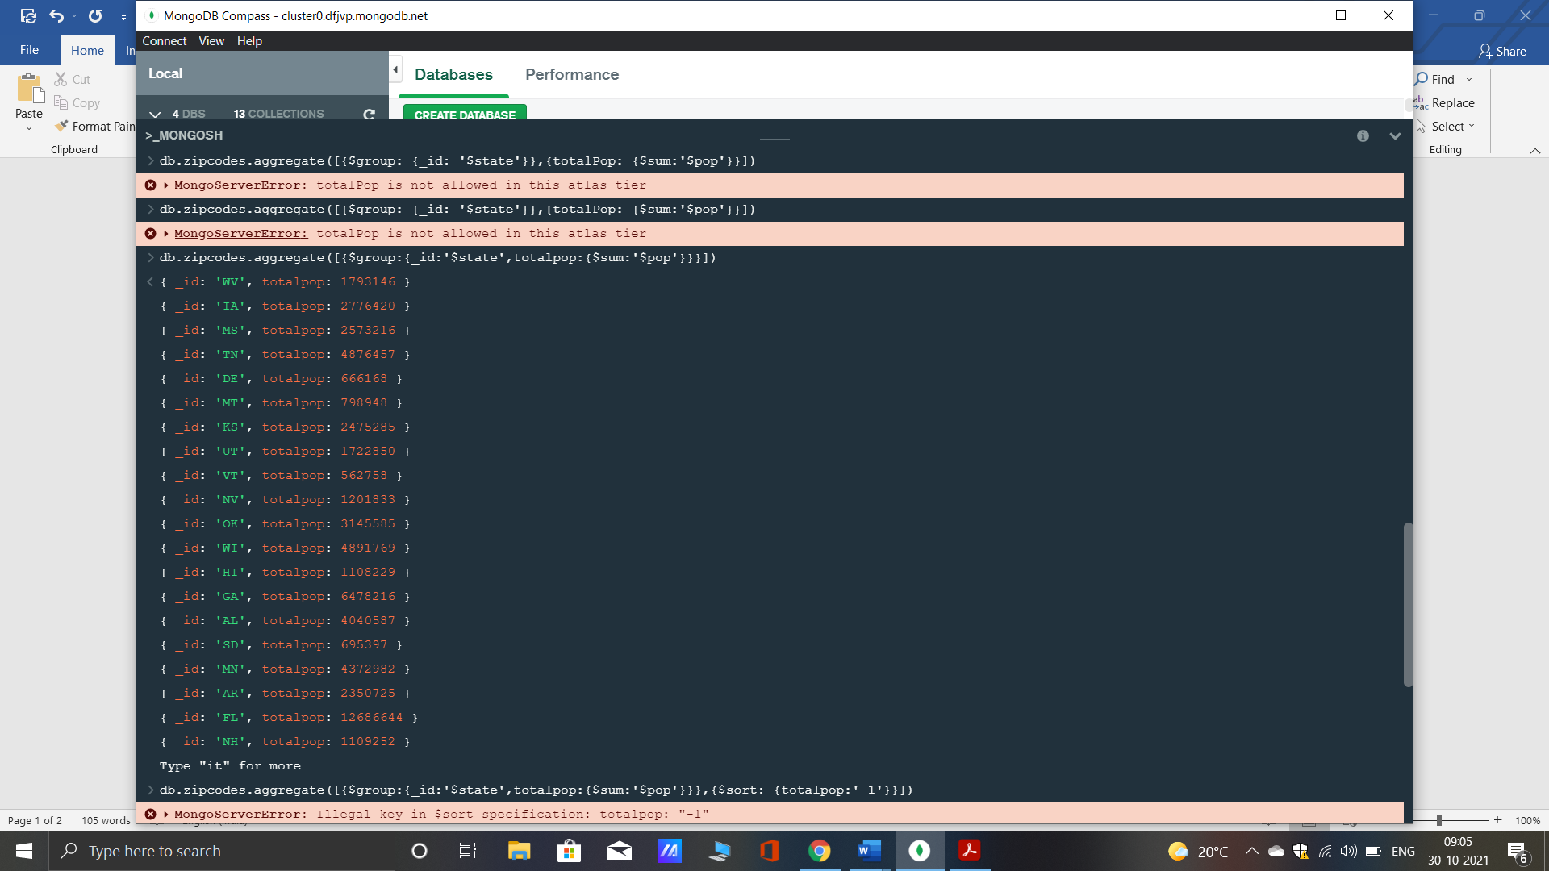

2. sort the results by population, highest first

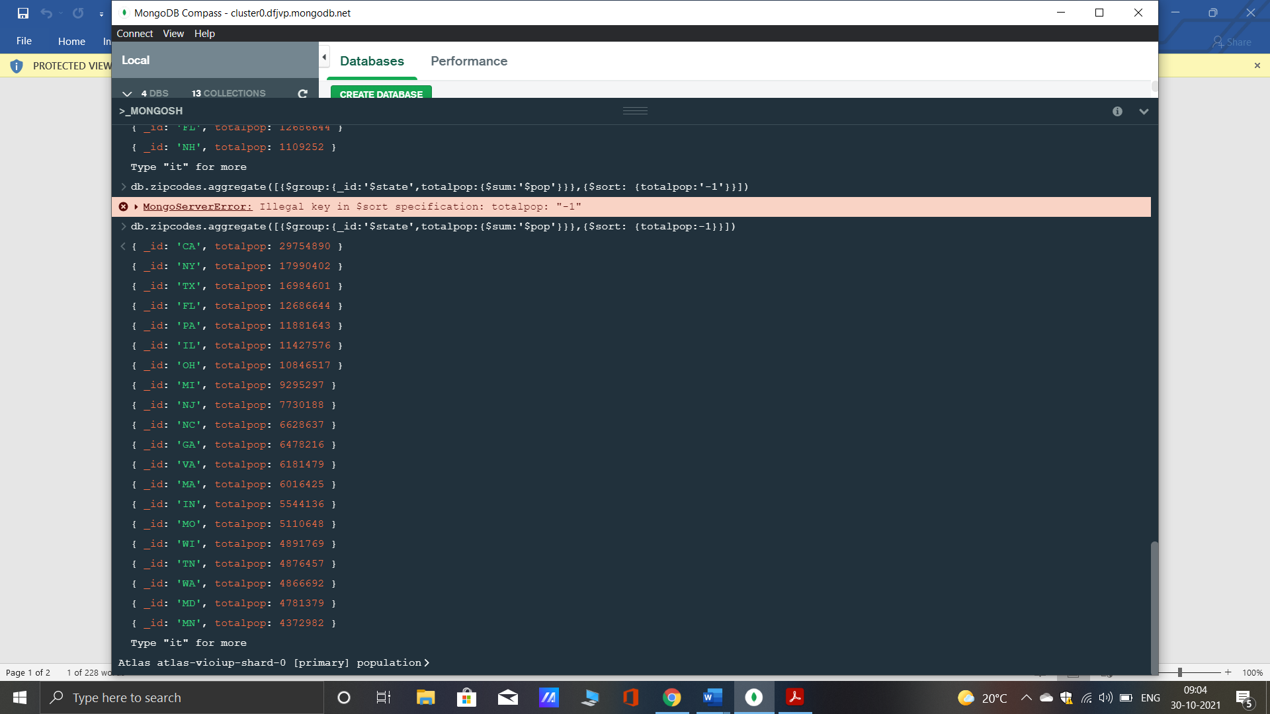

3. limit the results to just the first 3 results. What are the top 3 states in population?

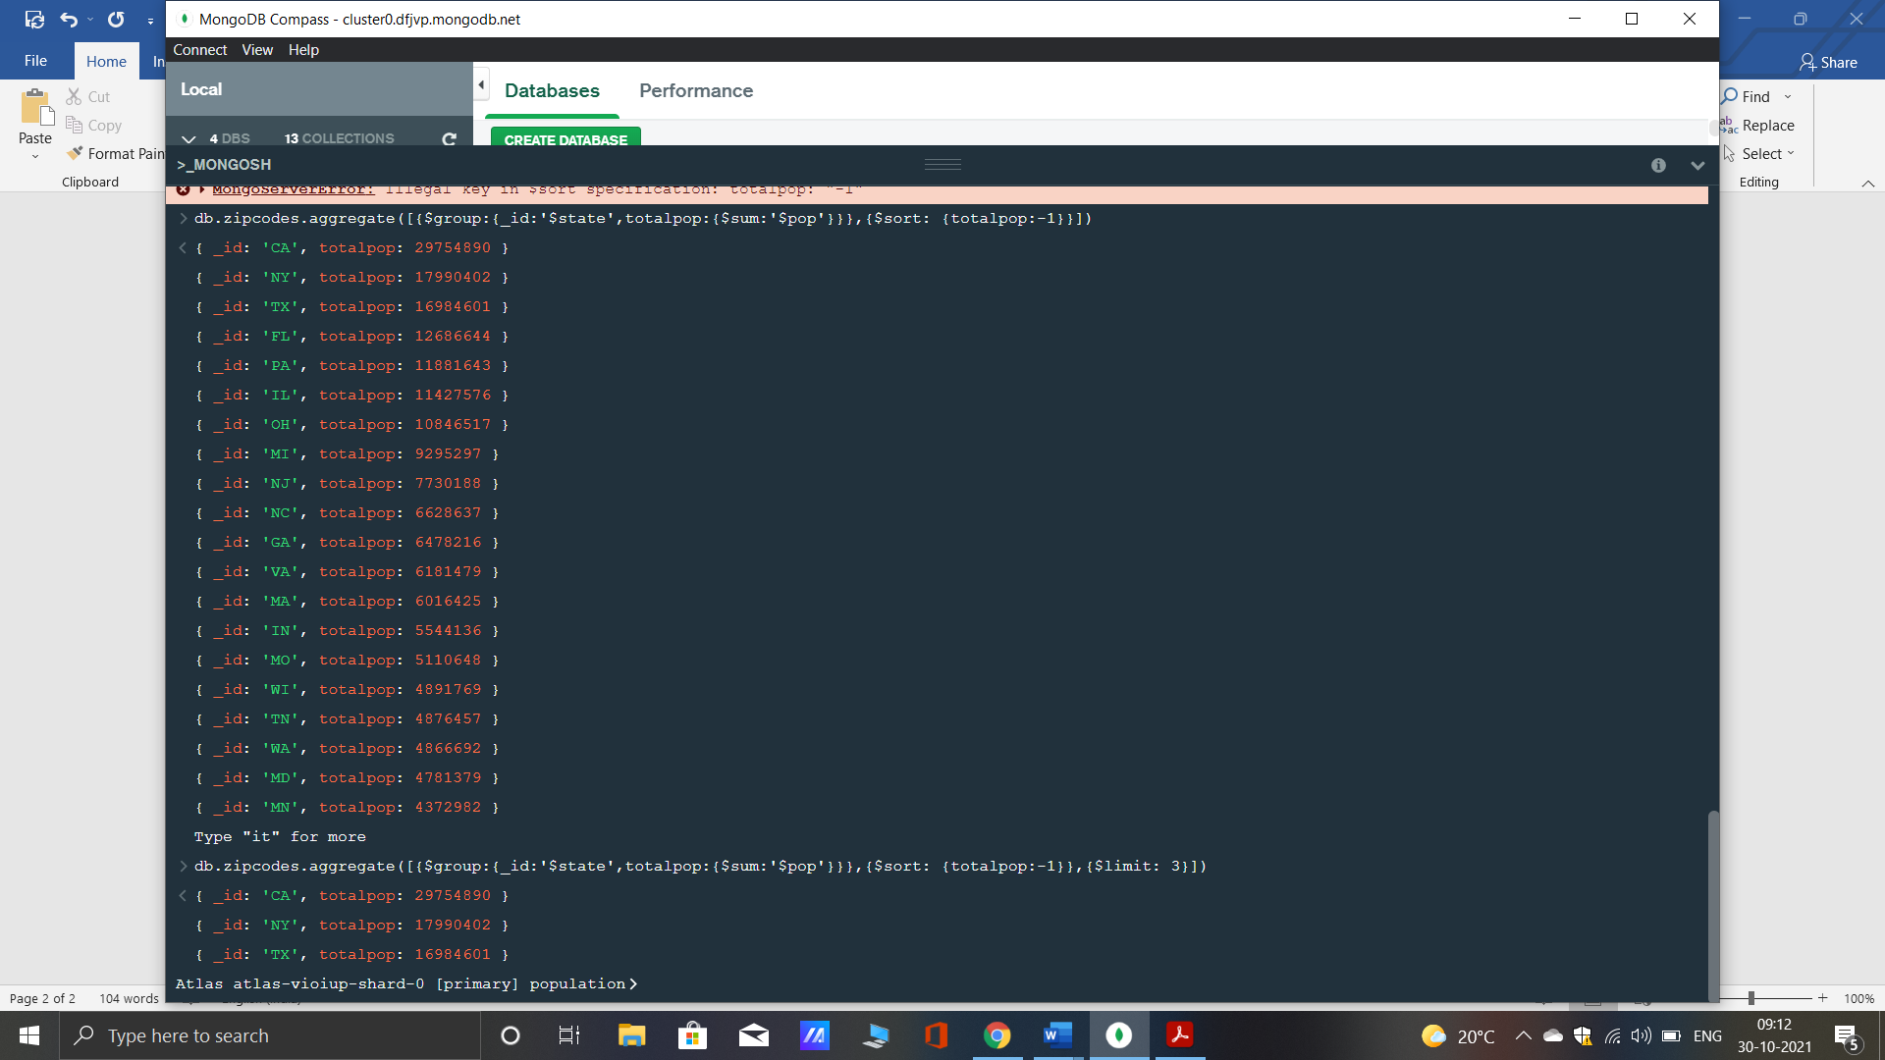

**Populations by City**

1.use aggregate to calculate the total population for each city (you have to use city/state combination). You can use a combination for the _id of the $group: { city: '$city', state: '$state' }

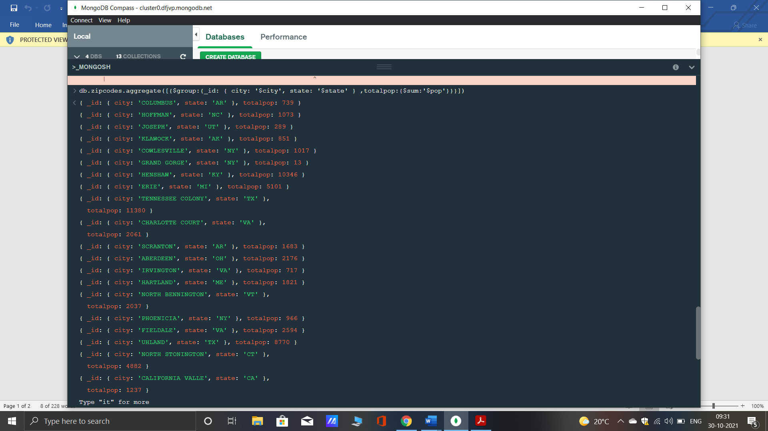

2. sort the results by population, highest first

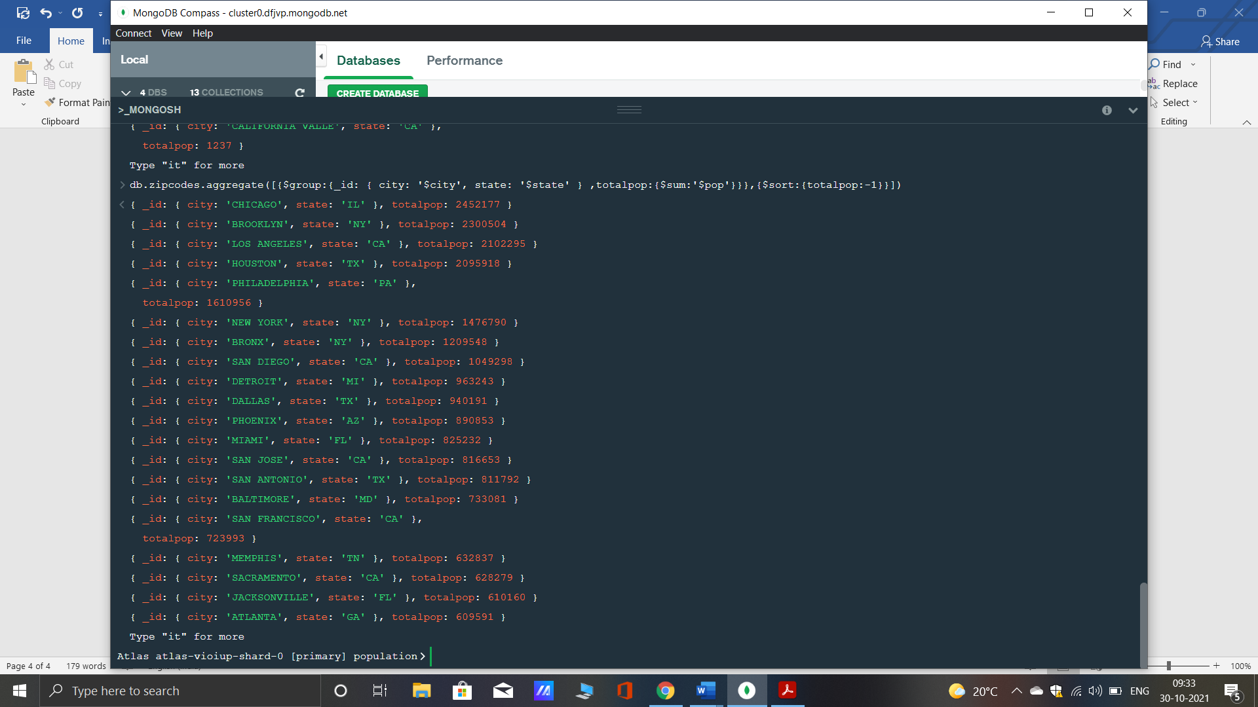

3. limit the results to just the first 3 results. What are the top 3 cities in population?

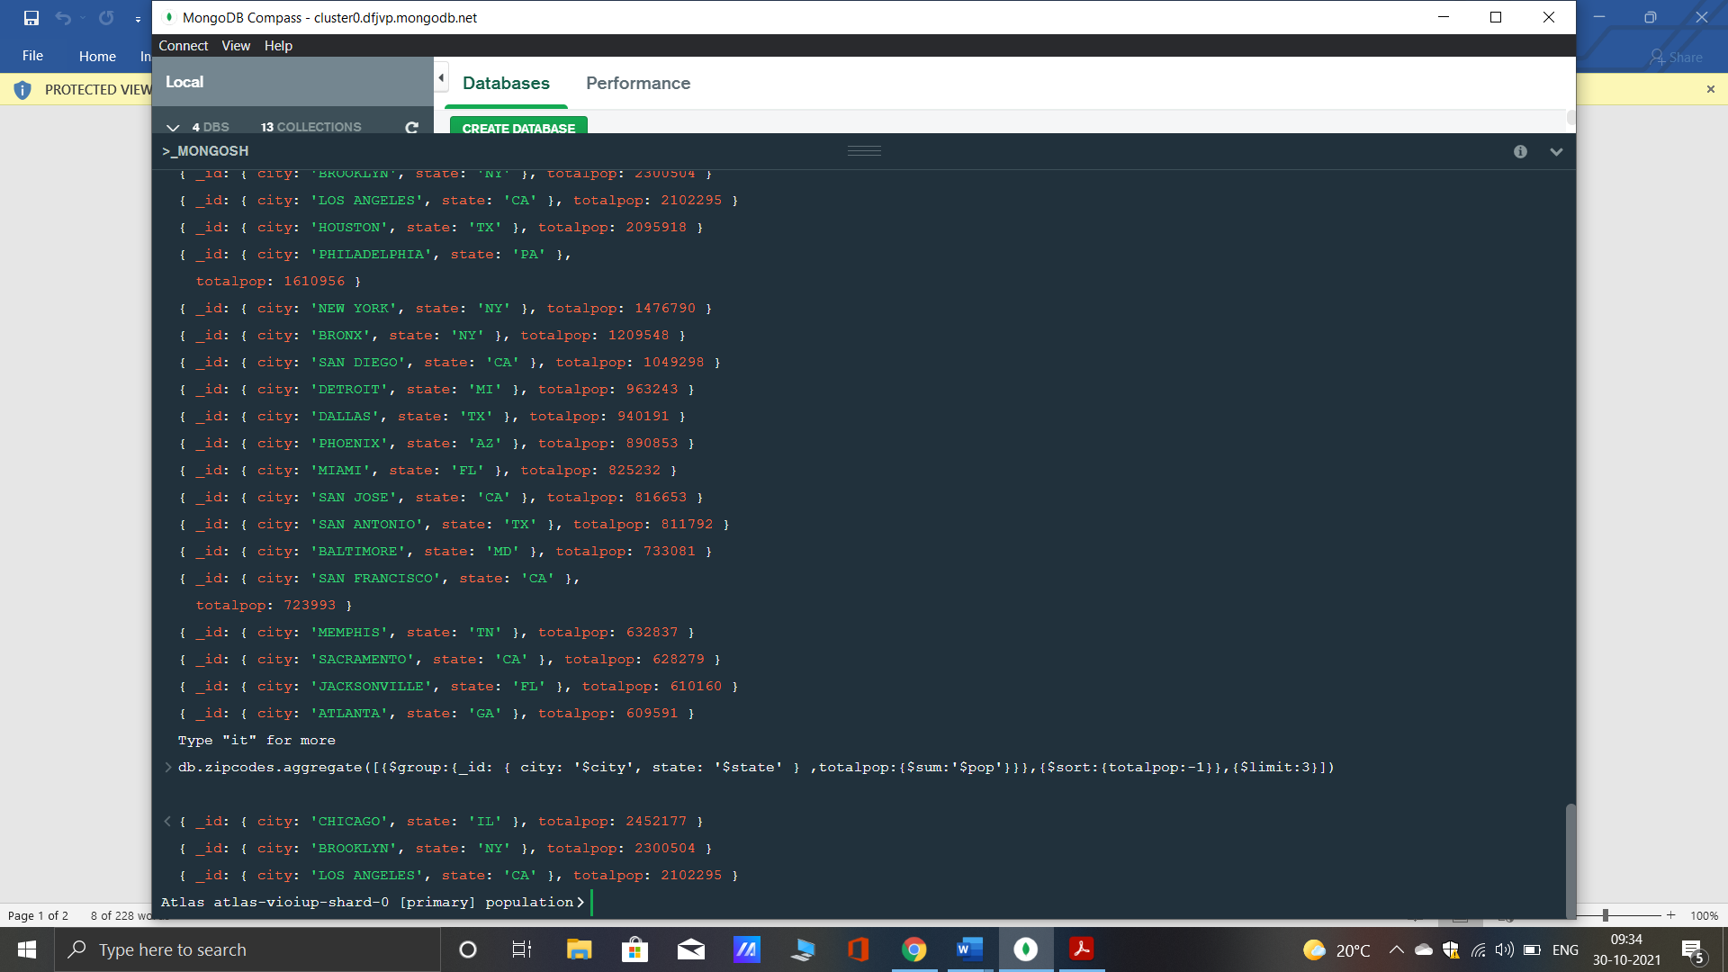

4. What are the top 3 cities in population in Texas?

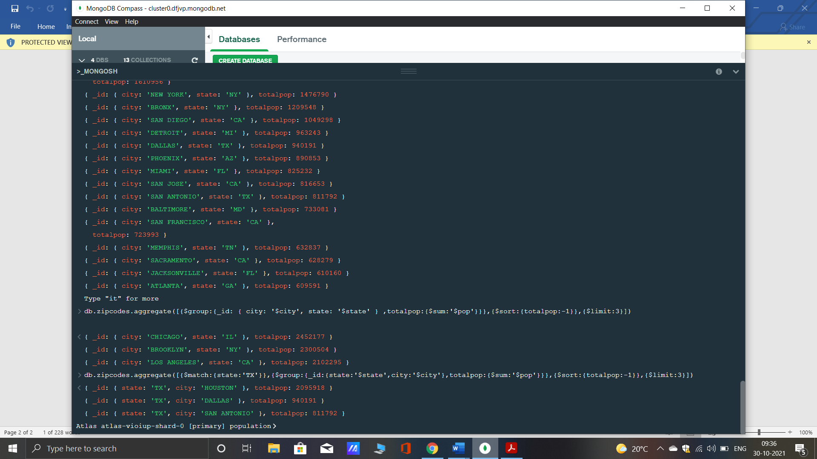

**Bonus**

1. Write a query to get the average city population for each state.

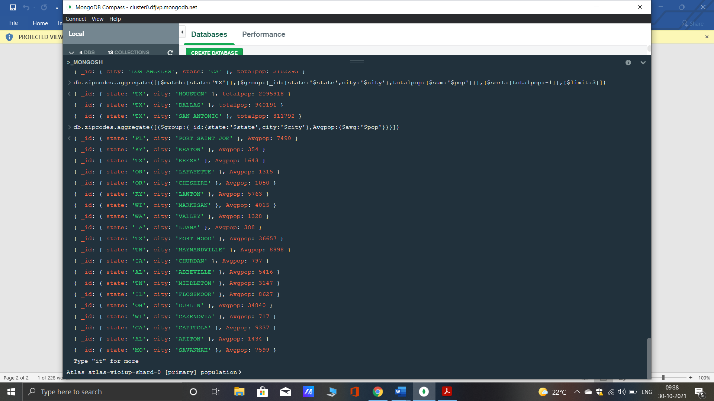

2. What are the top 3 states in terms of average city population

